Agenda for Monthly Board Meeting
Thursday August 13, 2026, 6 pm
Altamont Ambulance Shed

Pledge
Prayer
Attendance
Action Items:
Approve and Schedule a new Budget Hearing:
Board Member Reports:
Monthly Financials: Annissa Maxfield
Youth Sports: Annissa Maxfield
Update on Current Budget/Budget Hearing: Danelle Brinkerhoff
Altamont Park: Danelle Brinkerhoff/Becky Lee
Bluebell Park: Jordan Witbeck
Longhorn Days Update: Debbie Thayne
Rodeo Grounds/Events: Johny Thayne

Action Items – Amphitheater needs the nests pulled down and the soffit replaced
All invoices for the Rodeo Grounds need to be turned in and paid.
Agreements for use of the rodeo grounds Bylaw’s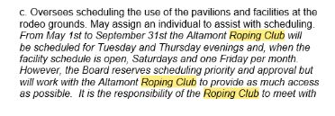
The Rodeo Committee and the Board to discuss and finalize scheduling.

